Module 5 Assignment - Nonparametric Methods and Sampling

Arun Radhakrishnan (002933307)

ALY6015: Intermediate Analytics
Instructor - Vivian Clements Edwin
October 23rd, 2023

Introduction:

Nonparametric statistical techniques are a category of statistical analysis that operates without the assumption of a specific data distribution. In contrast to parametric methods, which rely on precise mathematical models and distributions, nonparametric methods require fewer assumptions about the underlying data distribution. This quality makes them a valuable resource when dealing with data that doesn't conform to standard distributions or when the true distribution is unknown.

Examples of nonparametric statistical methods encompass the Wilcoxon rank-sum test, the Kruskal-Wallis test, the Mann-Whitney U test, and the Spearman rank correlation coefficient. These techniques find frequent application in fields like psychology, medicine, and the social sciences, where data often deviates from conventional distribution models.

Section 13-2 Game Attendance:

1. State the hypotheses and identify the claim.
Null Hypothesis (H0):
The median paid attendance at 20 local football games equals 3000.
Alternative Hypothesis (H1):
The median paid attendance at 20 local football games differs from 3000.

2. Find the critical value(s)
alpha = 0.05
3. Compute the test value.
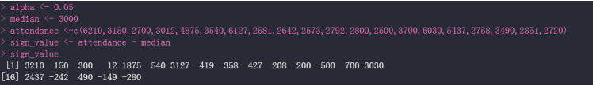
it's evident that numerous values surpass the 3000 threshold, while others are denoted by a negative sign, signifying values below 3000.
4. Make the decision.
The analysis reveals that the p-value obtained from the sign test, considering values both less than and greater than 3000, equals 1. This value exceeds the specified alpha level of 0.05. Consequently, we do not have sufficient evidence to warrant the rejection of the null hypothesis.
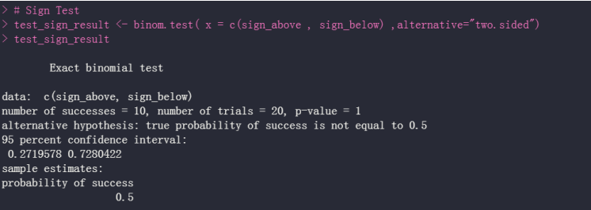
5. Summarize the results.
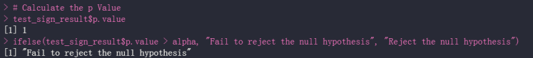
there is insufficient support to substantiate the assertion that the median paid attendance for the 20 local football games equals 3000. Therefore, we fail to reject the null hypothesis.

Section 13-2 Lottery Ticket Sales:

1. State the hypotheses and identify the claim.
Null Hypothesis (H0): The median number of lottery tickets sold by the outlet owner is 200 per day.
Alternative Hypothesis (H1): The median number of lottery tickets sold by the outlet owner is less than 200 per day.
2. Find the critical value(s)
alpha = 0.05
3. Compute the test value.
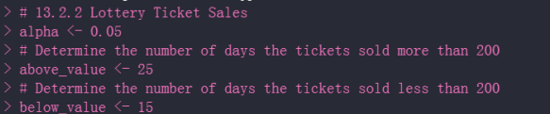
it becomes evident that there is a range of values where ticket sales exceed 200, as well as instances where sales fall below 200.

4. Make the decision.
we find that the p-value for the sign test involving lottery ticket sales of 200 is 0.9597. This p-value surpasses the predefined alpha level of 0.05. we fail to reject the null hypothesis.
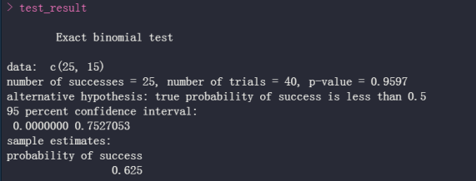
5. Summarize the results.
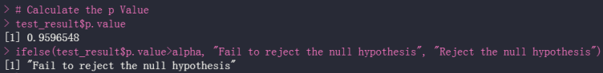
The available evidence does not strongly support the assertion that the median number of lottery tickets sold by the outlet owner equals 200 per day. Therefore, we fail to reject the null hypothesis.

Section 13-3 Lengths of Prison Sentences:

1. State the hypotheses and identify the claim.
Null Hypothesis (H0): There is no disparity in the sentences received by men and women.
Alternative Hypothesis (H1): A distinction exists in the sentences received by men and women.
2. Find the critical value(s)
alpha = 0.05
3. Compute the test value.
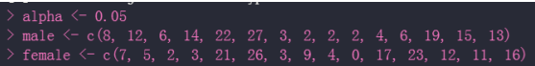
the data distribution among male and female values depicted in the image above.
4. Make the decision.
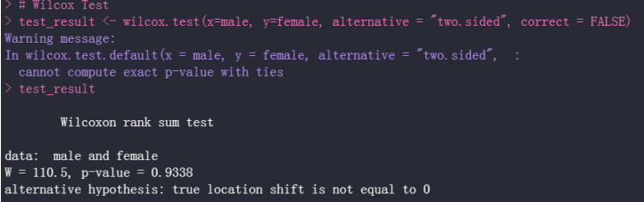
it is evident that the p-value for the test stands at 0.9338. This value exceeds the alpha level of 0.05; therefore, we fail to reject the null hypothesis.

5. Summarize the results.
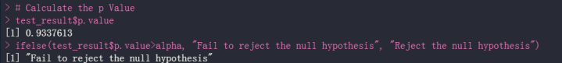
there isn't sufficient proof to substantiate the assertion that there is no distinction in the sentences received by men and women. Therefore, we fail to reject the null hypothesis.

Section 13-3 Winning Baseball Games:

1. State the hypotheses and identify the claim.
Null Hypothesis (H0): The number of wins does not differ significantly between the National League Eastern Division (NLED) and the American League Eastern Division (ALED).
Alternative Hypothesis (H1): There is a significant difference in the number of wins between the National League Eastern Division and the American League Eastern Division.
2. Find the critical value(s)
alpha = 0.05
3. Compute the test value.

the data distribution for both the National and American leagues provides insights into the test statistic.
4. Make the decision.
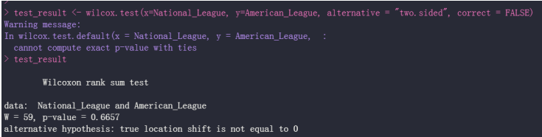
it is evident that the p-value for the test is 0.6657, exceeding the alpha value of 0.05. Consequently, we fail to reject the null hypothesis

5. Summarize the results.
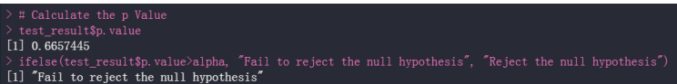
the data does not offer sufficient support for the assertion that there is no difference in the number of wins between the National League Eastern Division (NLED) and the American League Eastern Division (ALED). Thus, we fail to reject the null hypothesis.

Section 13-4 Use Table K:
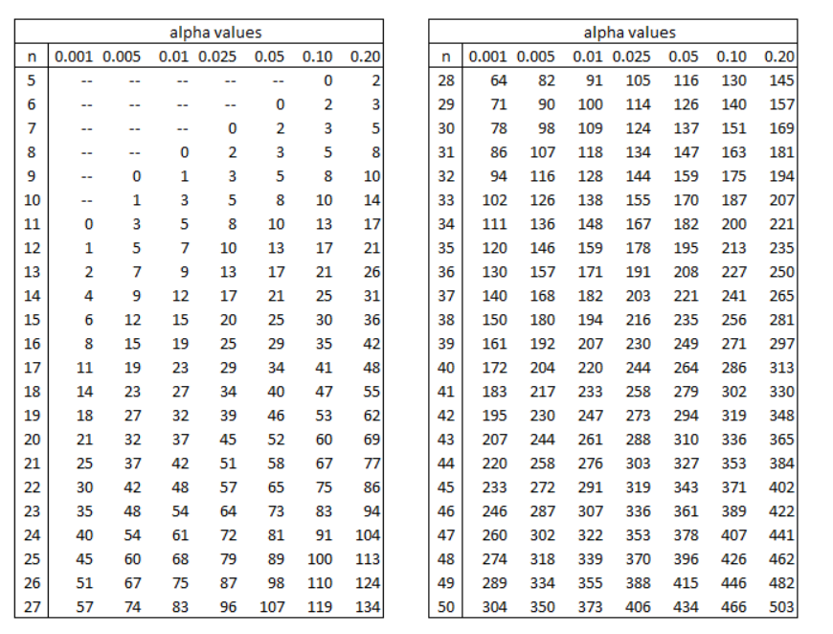
1. ws = 13, n = 15, α = 0.01, two-tailed
Solution: Critical value of w at n=15 and α = 0.01 is 16
Since ws < W ← 13 < 16 , the null hypothesis is not rejected.

2. ws = 32, n = 28, α = 0.025, one-tailed
Solution: z= 117 and Since, 32 < 117, the null hypothesis is rejected

3. ws = 65, n = 20, α = 0.05, one-tailed
Solution: z=60 and since 65 > 60, the null hypothesis is not rejected

4. ws = 22, n = 14, α = 0.10, two-tailed
Solution: z=26, and since 22<26, the null hypothesis is rejected.

Section 13-5 Mathematics Literacy Score:

1. State the hypotheses and identify the claim.
Null Hypothesis (H0): The mean mathematics literacy scores for 15-year-olds are the same across various countries.
Alternative Hypothesis (H1): The mean mathematics literacy scores for 15-year-olds differ among different countries.
2. Find the critical value(s)
alpha = 0.05
3. Compute the test value.

the data distribution across Western Hemisphere, Europe, and Eastern Africa, we can proceed with the analysis.

4. Make the decision.
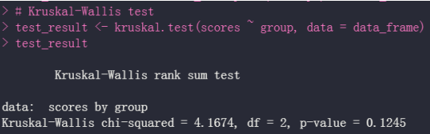
the computed p-value for the test is 0.1245, which exceeds the predetermined alpha value of 0.05. Consequently, we do not have sufficient evidence to reject the null hypothesis.

5. Summarize the results.
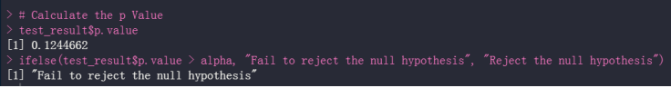
the available data does not provide substantial support for the assertion that there are significant differences in the mean mathematics literacy scores among 15-year-olds in various countries. Therefore, we fail to reject the null hypothesis.

Section 13-6 Subway and Commuter Rail Passengers:

1. State the hypotheses and identify the claim.
Null Hypothesis (H0): There is no correlation between the daily passenger trips for subways and commuter rail services in the chosen cities.
Alternative Hypothesis (H1): There exists a correlation between the daily passenger trips for subways and commuter rail services in the selected cities.
2. Find the critical value(s)
alpha = 0.05
3. Compute the test value.

we can observe the distribution of data points across different aspects such as city, subway, and rail transportation.
4. Make the decision.
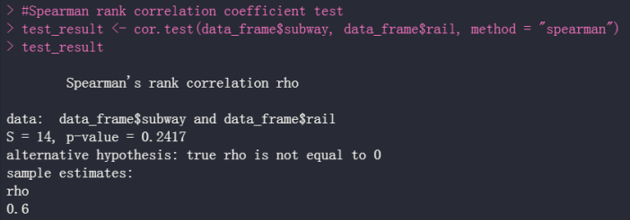
it becomes evident that the p-value for the test is 0.2417. This value exceeds the alpha level of 0.05, leading us to the conclusion that we do not have sufficient evidence to reject the null hypothesis.

5. Summarize the results.
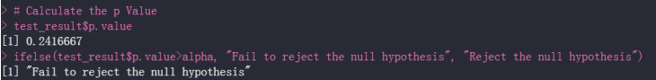
there is insufficient substantiation to affirm the assertion that there is no connection between the daily passenger trips for subways and commuter rail services in the chosen cities. Consequently, we fail to reject the null hypothesis.

Section 14-3 Prizes in Caramel Corn Boxes:

Question: A caramel corn company gives four different prizes, one in each box. They are placed in the boxes at random. Find the average number of boxes a person needs to buy to get all four prizes. (40)

Step 1: Creating a Function to Determine if All Four Prizes Need to Be Purchased.





Outcome:
The specific experiment yielded a result of 9

Step 2: Replicating the Experiment 40 Times to Attain the Desired Outcome:

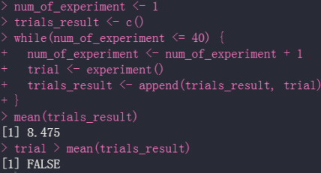

Observation:
• The trials_required indicate that, on average, 8 to 9 purchases are needed to obtain all four prizes.
• The observed trial value is 9, slightly exceeding the mean trial value of 8.475, which is why it is indicated as FALSE in the image above.
• It's important to note that this experiment is generated through a random process, so the outcomes can fluctuate each time the code is executed.

Section 14-3 Lottery Winner:

Question: To win a certain lotto, a person must spell the word big. Sixty percent of the tickets contain the letter b, 30% contain the letter i, and 10% contain the letter g. Find the average number of tickets a person must buy to win the prize. (30)

Step 1: Establishing an Investigation to Determine the Required Number of Tickets for Winning a Prize.



Outcome:
This experiment yielded a result of 12


Step 2: Replicating the Experiment 30 Times and Computing the Mean for Winning the Prize.

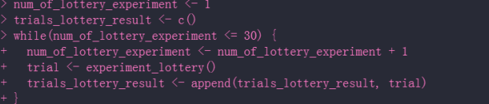

Step 3: Recording the Lottery Outcomes across All 30 Trials.

Step 4: Calculating the Average Outcome from the 30 Experiments.



Observations:

- Based on the above experiment, it is ascertained that, on average, an individual needs to purchase approximately 10 tickets to secure a lottery victory.
- It's essential to acknowledge that this experiment is inherently stochastic, and as such, the results may vary each time the code is executed.

Conclusion

Nonparametric statistical techniques and sampling serve as crucial instruments in data analysis, offering valuable perspectives into the inherent structures and associations within a dataset. This is particularly valuable when the true data distribution is uncertain or doesn't conform to established models. The nonparametric tests covered in this module include the sign test, Wilcoxon rank sum test, signed rank test, Spearman rank coefficient correlation test, and the runs test.

Reference

- Robert Kabacoff - robk@statmethods.net. (n.d.). Quick-R: Nonparametric Statistics. https://www.statmethods.net/stats/nonparametric.html
- Wilcoxon Signed-Rank Test | R Tutorial. (n.d.). Copyright © 2009 - 2010 Chi Yau. All Rights Reserved. https://www.r-tutor.com/elementary-statistics/non-parametric-methods/wilcoxon-signed-rank-test

APPENDIX



